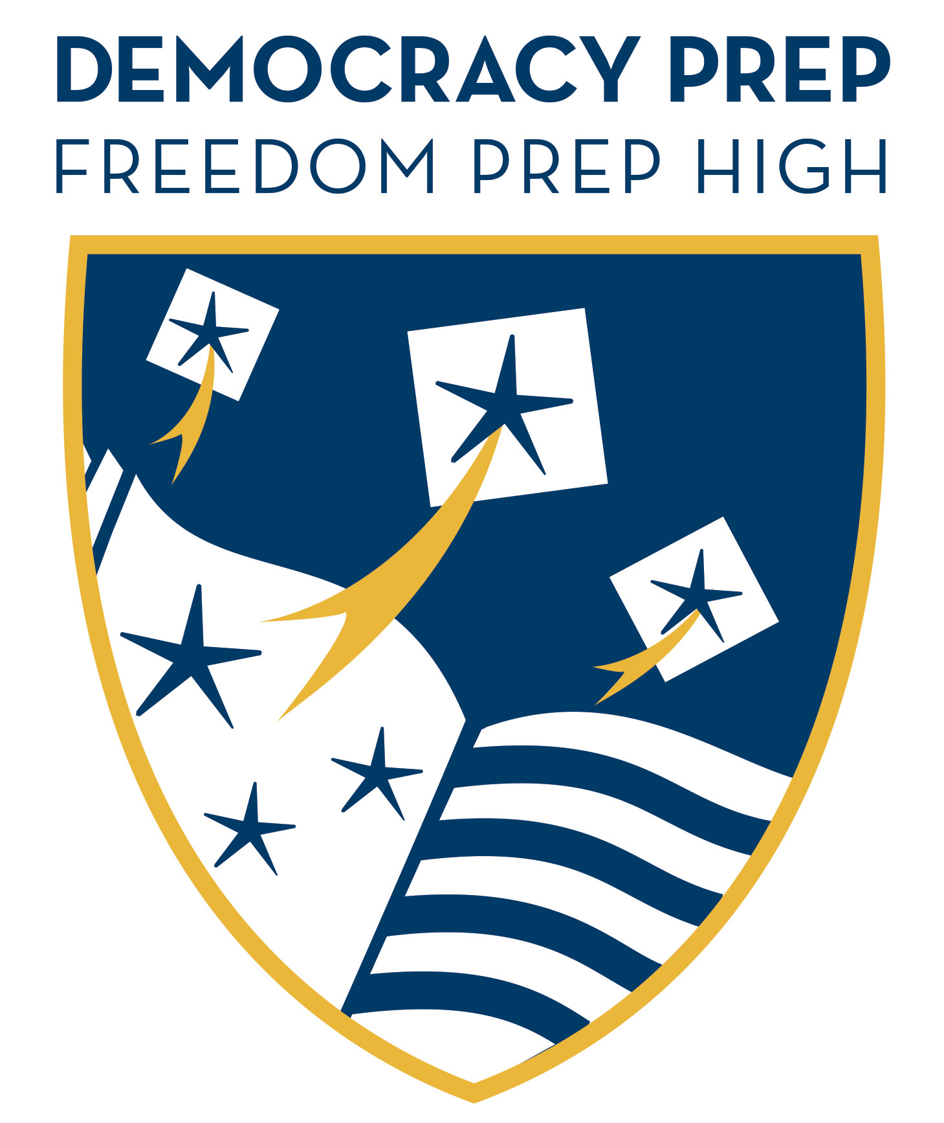
Anti-Bullying Bill of Rights Grade Report 2014 - 2015
Freedom Prep High School Grade: 42 of 78
Freedom Prep Charter School Grade: 42 of 78

Overview
On January 5, 2011, the Anti-Bullying Bill of Rights Act (P.L.2010, c.122, (which can be found here) was signed into law to strengthen the standards and procedures for preventing, reporting, investigating and responding to incidents of harassment, intimidation and bullying (HIB) of students that occur on school grounds and off school grounds under specified circumstances. The law was adopted, in part, in response to research on the incidence, prevalence and effects of HIB that has emerged since the adoption of the original HIB law in 2002.
Definition
Under New Jersey law, “harassment, intimidation, or bullying” means any gesture, any written, verbal or physical act, or any electronic communication, whether it be a single incident or a series of incidents, that:
- Is reasonably perceived as being motivated either by an actual or perceived characteristic, such as race, color, religion, ancestry, national origin, gender, sexual orientation, gender identity and expression, or a mental, physical or sensory disability, or by any other distinguishing characteristic;
- Takes place on school property, at any school-sponsored function, or on a school bus; or off school grounds, as provided for in N.J.S.A. 18A:37-15.3,
- Substantially disrupts or interferes with the orderly operation of the school or the rights of other students; and that
- A reasonable person should know, under the circumstances, will have the effect of physically or emotionally harming a student or damaging the student’s property, or placing a student in reasonable fear of physical or emotional harm to his person or damage to his property; or
- Has the effect of insulting or demeaning any student or group of students; or
- Creates a hostile educational environment for the student by interfering with a student’s education or by severely or pervasively causing physical or emotional harm to the student

